**Q3-Ansible Document**

Organize project directory

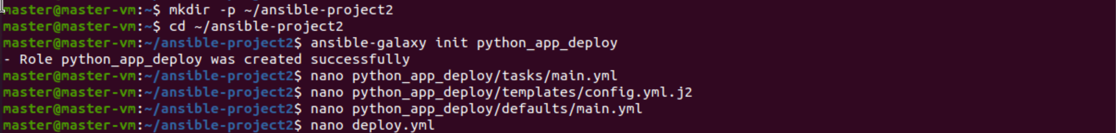

Templates-file

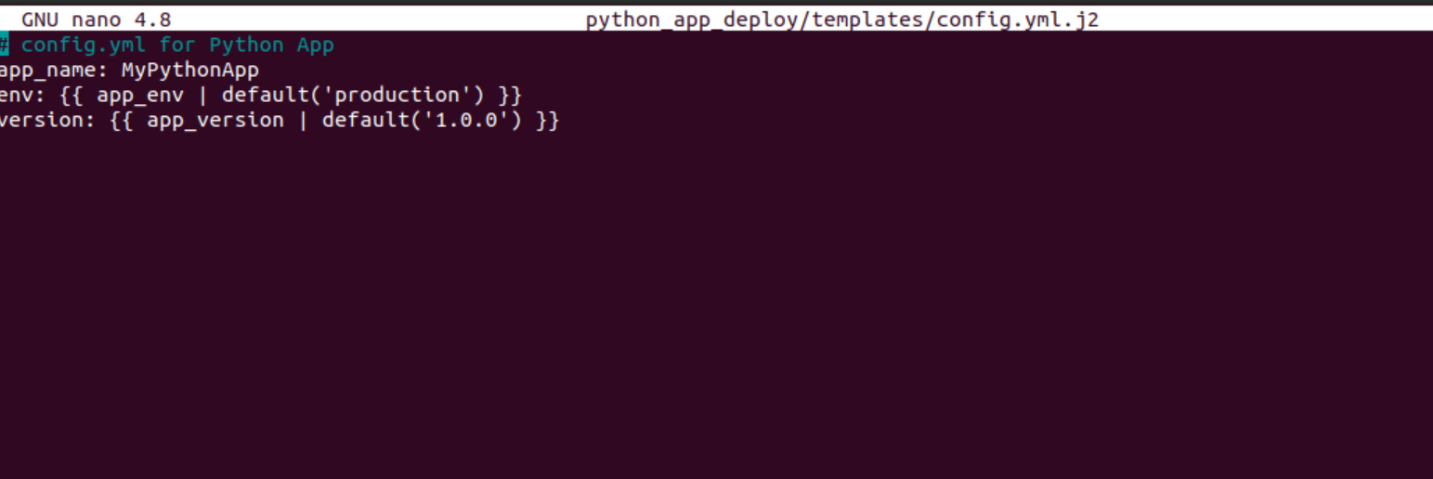

Defaults and Taks yaml files:

Runinng the playbook

